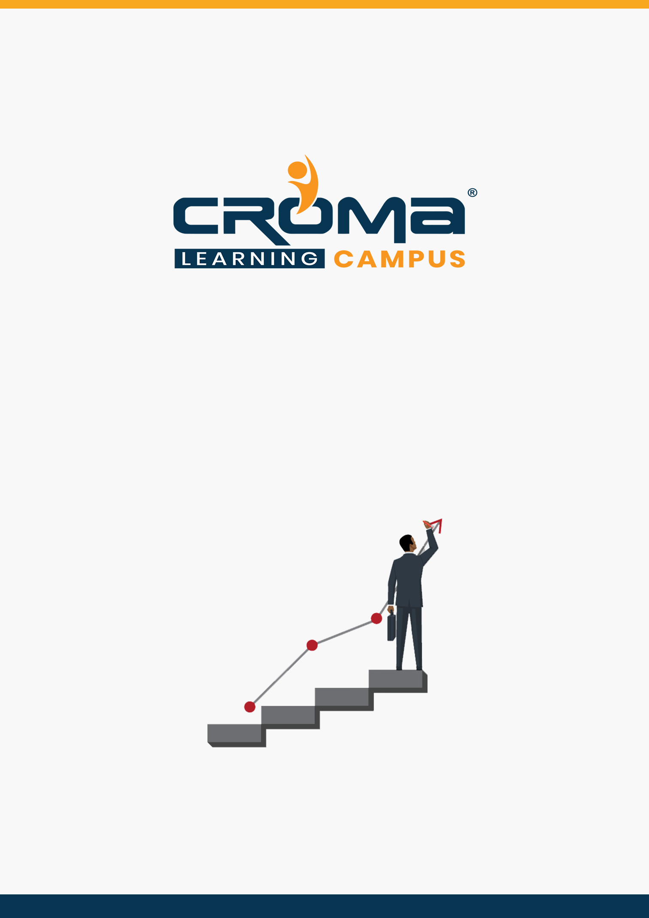

**AZ-204 Developing Solutions for Microsoft Azure Training Curriculum**

**STRUCTURE**

**www.cromacampus.com | helpdesk@cromacampus.com | +91-120-4155255**

**AZ-204 Developing Solutions for Microsoft Azure Training Curriculum**

*“Learn building, managing, and securing Microsoft Azure solutions with our detailed curriculum plan.”*

**Course Objectives:**

* Prepare yourself for the certification exam and clear your certification exam in the first attempt
* Add an attractive credential in your resume that is really appreciated by Companies.
* Improve your overall Cloud management skills, azure development skills, and explore more job prospects with better salary packages.
* Boost your social media profiles especially LinkedIn by adding this certification and become one of the top persons to be chosen by industries.

**AZ 204 Certification Training Description:**

Our AZ-204 “Developing Solutions for Microsoft Azure” certification Training is geared towards Azure Developers who design and build cloud solutions such as applications and services. They participate in all phases of development, from solution design, to development and deployment, to testing and maintenance. They partner with cloud solution architects, cloud DBAs, cloud administrators, and clients to implement the solution.

***Here are some strong reasons why should you consider this certification course.***

* Validate your technical skills like storage, networking, compute, security, and other Cloud operations on Microsoft Azure.
* Validate your development skills and showcase your expertize in building cloud solutions, apps, and services.
* Top-paying info-tech certification in the world.
* It provides you with global recognition for your knowledge, skills, and experience.
* The organization looks for those who know Oracle Cloud, AWS, Azure, etc.

**Prerequisites for the Certification Exam:**

* To attempt for this certification, you should be proficient in developing apps and services by using Azure tools and technologies, including storage, security, compute, and communications. Basically, you must have Azure admin skills or you are advised to attempt for *AZ 103 Azure admin Associate Certification* exam first before you attempt for the AZ 204, Azure Developer Associate.
* Also, you must have at least one year of experience developing scalable solutions through all phases of software development and be skilled in at least one cloud-supported programming language.

**Necessary Details about Certification You Must Know**

* Certification Name – AZ-204 Developing Solutions for Microsoft Azure
* Exam Duration: 150 minutes
* Number of Questions: 40-60
* Passing score: 700 (Out of 1000)
* Exam Cost: USD 165.00
* Validity: 2 years

**Certification Exam Structure:**

* Develop Azure compute solutions (25-30%)
* Develop for Azure storage (10-15%)
* Implement Azure security (15-20%)
* Monitor, troubleshoot, and optimize Azure solutions (10-15%)
* Connect to and consume Azure services and third-party services (25-30%)

**Course Content:**

**Module 1: Develop Azure Compute Solution**

* Introduction
  + Introduction to Cloud Computing
  + Microsoft Azure Overview
  + Microsoft Azure Services
  + Azure Subscriptions
  + Azure Resource Groups
  + Organizing Azure Resources
  + What are Virtual Machines?
  + Introduction to ARM Templates
  + What are batch Jobs and Azure Batch Services?
  + What is Kubernetes?
* Implement IaaS solutions
  + provision VMs configure VMs for remote access
  + create ARM templates
  + create container images for solutions by using Docker
  + publish an image to the Azure Container Registry
  + run containers by using Azure Container Instance
  + Azure Kubernetes Service (AKS) is out of scope
* Create Azure App Service Web Apps
  + create an Azure App Service Web App
  + enable diagnostics logging
  + deploy code to a web app
  + configure web app settings including SSL, API, and connection strings
  + implement auto scaling rules, including scheduled auto scaling, and scaling by operational or system metrics
* Implement Azure functions
  + implement input and output bindings for a function
  + implement function triggers by using data operations, timers, and web-hooks
  + implement Azure Durable Functions

**Module 2: Develop for Azure storage**

* Develop solutions that use Cosmos DB storage
  + select the appropriate API for your solution
  + implement partitioning schemes
  + interact with data using the appropriate SDK
  + set the appropriate consistency level for operations
  + create Cosmos DB containers
  + implement scaling (partitions, containers)
  + implement server-side programming including stored procedures, triggers, and change feed notifications
* Develop solutions that use blob storage
  + move items in Blob storage between storage accounts or containers
  + set and retrieve properties and metadata
  + interact with data using the appropriate SDK
  + implement data archiving and retention
  + implement hot, cool, and archive storage

**Module 3: Implement Azure security**

* Implement user authentication and authorization
  + implement OAuth2 authentication
  + create and implement shared access signatures
  + register apps and use Azure Active Directory to authenticate users
  + control access to resources by using role-based access controls (RBAC)
* Implement secure cloud solutions
  + secure app configuration data by using the App Configuration and KeyVault API
  + manage keys, secrets, and certificates by using the KeyVault API
  + implement Managed Identities for Azure resources

**Module 4: Monitor, troubleshoot, and optimize solutions**

* Integrate caching and content delivery within solutions
  + develop code to implement CDN’s in solutions
  + configure cache and expiration policies for Front Door, CDNs, or Redis caches
  + store and retrieve data in Azure Redis cache
* Instrument solutions to support monitoring and logging
  + configure instrumentation in an app or service by using Application Insights
  + analyze log data and troubleshoot solutions by using Azure Monitor
  + implement Application Insights Web Test and Alerts
  + implement code that handles transient faults

**Module 5: Connect to and consume Azure and third-party services**

* Develop an App Service Logic App
  + create a Logic App
  + create a custom connector for Logic Apps
  + create a custom template for Logic Apps
* Implement API Management
  + create an APIM instance
  + configure authentication for APIs
  + define policies for APIs
* Develop event-based solutions
  + implement solutions that use Azure Event Grid
  + implement solutions that use Azure Notification Hubs
  + implement solutions that use Azure Event Hub
* Develop message-based solutions
  + implement solutions that use Azure Service Bus
  + implement solutions that use Azure Queue Storage queues

**Module 6: Placement Guide**

* Tips to clear an Interview
* Common Interview questions and answers
* AZ 204 Interview Questions and Answers
* Resume Building Guide
* Attempt for AZ 204 Global Certification Exam
* Start applying for Jobs